**Lab Report 5 & 6**

**Digital Image Processing**

**CSE438**

**Section:** 03

**Semester:** Spring-2025

**Submitted To:**

**Md. Asif Khan Rifat**

**Lecturer**

Department of Computer Science

and Engineering

**Submitted By:**

                                                                         Suddip Paul Arnab

**2022-1-60-356**

**Date of submission:** 7 May 2025

1. **Apply** Fourier transform to transform any image (above) from the spatial domain to the frequency domain. Apply inverse Fourier transform to transform the image from the frequency domain to the spatial domain.

original_img = imread('Picture1.jpg');

gray_img = rgb2gray(original_img);

gray_img = im2double(gray_img);

% Fourier Transform

F = fft2(gray_img); % Apply 2D Fourier Transform

F_shifted = fftshift(F); % Shift zero-frequency to the center

% Magnitude Spectrum for visualization

magnitude_spectrum = log(1 + abs(F_shifted));

% Inverse Fourier Transform

F_ishifted = ifftshift(F_shifted); % Inverse shift

reconstructed_img = ifft2(F_ishifted);% Apply Inverse Fourier Transform

reconstructed_img = abs(reconstructed_img); % Take magnitude (real part)

% Display Results

figure('Name','Fourier Transform and Inverse', 'NumberTitle','off');

subplot(1,3,1), imshow(gray_img, []), title('Original Image');

subplot(1,3,2), imshow(magnitude_spectrum, []), title('Magnitude Spectrum');

subplot(1,3,3), imshow(reconstructed_img, []), title('Reconstructed Image');

1. **Apply** three types of high pass filtering in the frequency domain in **Figure 1** andfind out which one is better to produce the enhanced image (sharpen) for the given image (output must show all steps as shown in **Figure 2**).

i. Ideal high pass filter (IHPF)

img = imread('Picture4.jpg');

if size(img,3) == 3

gray_img = img(:,:,1)*0.2989 + img(:,:,2)*0.5870 + img(:,:,3)*0.1140;

else

gray_img = img;

end

F = fft2(double(gray_img));

F_shifted = fftshift(F);

[M, N] = size(gray_img);

D0 = 90;

[X, Y] = meshgrid(1:N, 1:M);

D = sqrt((X - N/2).^2 + (Y - M/2).^2);

n = 2;

IHPF = double(D > D0);

F_filtered = F_shifted .* IHPF;

F_ishifted = ifftshift(F_filtered);

processed_img = abs(ifft2(F_ishifted));

figure("Name","Ideal high pass filter","NumberTitle","on");

sgtitle('Ideal high pass filter','FontSize', 18);

subplot(2,3,1), imshow(gray_img, []);

xlabel('(a) Original Image', 'FontSize', 12);

subplot(2,3,2), imshow(log(1+abs(F_shifted)), []), xlabel('(b) Centered Fourier Spectrum', 'FontSize', 12);

subplot(2,3,3), imshow(IHPF, []), xlabel('(c) Ideal high pass filter', 'FontSize', 12);

subplot(2,3,4), mesh(IHPF), xlabel('(d) Ideal high pass filter', 'FontSize', 12);

axis tight;

subplot(2,3,5), imshow(log(1+abs(F_filtered)), []), xlabel('(e) Filtered Fourier Spectrum', 'FontSize', 12);

subplot(2,3,6), imshow(processed_img, []), xlabel('(f) Processed Image', 'FontSize', 12);

ii. Butterworth high pass filter (BHPF)

img = imread('Picture4.jpg');

if size(img,3) == 3

gray_img = img(:,:,1)*0.2989 + img(:,:,2)*0.5870 + img(:,:,3)*0.1140;

else

gray_img = img;

end

F = fft2(double(gray_img));

F_shifted = fftshift(F);

[M, N] = size(gray_img);

D0 = 90;

[X, Y] = meshgrid(1:N, 1:M);

D = sqrt((X - N/2).^2 + (Y - M/2).^2);

n = 2;

BHPF = 1 ./ (1 + (D0 ./ D).^(2*n));

F_filtered = F_shifted .* BHPF;

F_ishifted = ifftshift(F_filtered);

processed_img = abs(ifft2(F_ishifted));

figure("Name","Butterworth high pass filter","NumberTitle","on");

sgtitle('Butterworth high pass filter','FontSize', 18);

subplot(2,3,1), imshow(gray_img, []);

xlabel('(a) Original Image', 'FontSize', 12);

subplot(2,3,2), imshow(log(1+abs(F_shifted)), []), xlabel('(b) Centered Fourier Spectrum', 'FontSize', 12);

subplot(2,3,3), imshow(BHPF, []), xlabel('(c) Butterworth high pass filter', 'FontSize', 12);

subplot(2,3,4), mesh(BHPF), xlabel('(d) Butterworth high pass filter', 'FontSize', 12);

axis tight;

subplot(2,3,5), imshow(log(1+abs(F_filtered)), []), xlabel('(e) Filtered Fourier Spectrum', 'FontSize', 12);

subplot(2,3,6), imshow(processed_img, []), xlabel('(f) Processed Image', 'FontSize', 12);

iii. Gaussian high pass filter (GHPF)

img = imread('Picture4.jpg');

if size(img,3) == 3

gray_img = img(:,:,1)*0.2989 + img(:,:,2)*0.5870 + img(:,:,3)*0.1140;

else

gray_img = img;

end

F = fft2(double(gray_img));

F_shifted = fftshift(F);

[M, N] = size(gray_img);

D0 = 90;

[X, Y] = meshgrid(1:N, 1:M);

D = sqrt((X - N/2).^2 + (Y - M/2).^2);

n = 2;

GHPF = 1 - exp(-(D.^2) / (2*(D0^2)));

F_filtered = F_shifted .* GHPF;

F_ishifted = ifftshift(F_filtered);

processed_img = abs(ifft2(F_ishifted));

figure("Name","Gaussian high pass filter","NumberTitle","on");

sgtitle('Gaussian high pass filter','FontSize', 18);

subplot(2,3,1), imshow(gray_img, []);

xlabel('(a) Original Image', 'FontSize', 12);

subplot(2,3,2), imshow(log(1+abs(F_shifted)), []), xlabel('(b) Centered Fourier Spectrum', 'FontSize', 12);

subplot(2,3,3), imshow(GHPF, []), xlabel('(c) Gaussian high pass filter', 'FontSize', 12);

subplot(2,3,4), mesh(GHPF), xlabel('(d) Gaussian high pass filter', 'FontSize', 12);

axis tight;

subplot(2,3,5), imshow(log(1+abs(F_filtered)), []), xlabel('(e) Filtered Fourier Spectrum', 'FontSize', 12);

subplot(2,3,6), imshow(processed_img, []), xlabel('(f) Processed Image', 'FontSize', 12);

Among the three high pass filters applied—Ideal, Butterworth, and Gaussian—the Gaussian High Pass Filter (GHPF) produced the most visually pleasing result. While the Ideal HPF offered strong edge enhancement, it introduced noticeable ringing artifacts. The Butterworth HPF provided a balance between sharpening and smoothness but still showed minor distortions. In contrast, the GHPF delivered natural-looking enhancement without artifacts, making it the best choice for image sharpening.

1. **Apply** three types of low pass filtering in the frequency domain in **Figure 1** andfind out which one is better to produce the smoothen image for the given image (output must show all steps as shown in **Figure 2**).

i. Ideal low pass filter (ILPF)

img = imread('Picture4.jpg');

if size(img,3) == 3

gray_img = img(:,:,1)*0.2989 + img(:,:,2)*0.5870 + img(:,:,3)*0.1140;

else

gray_img = img;

end

F = fft2(double(gray_img));

F_shifted = fftshift(F);

[M, N] = size(gray_img);

D0 = 90;

[X, Y] = meshgrid(1:N, 1:M);

D = sqrt((X - N/2).^2 + (Y - M/2).^2);

% Ideal Low Pass Filter

ILPF = double(D <= D0);

% Apply filter in frequency domain

F_filtered = F_shifted .* ILPF;

F_ishifted = ifftshift(F_filtered);

processed_img = abs(ifft2(F_ishifted));

% Visualization

figure("Name","Ideal Low Pass Filter","NumberTitle","on");

sgtitle('Ideal Low Pass Filter','FontSize', 18);

subplot(2,3,1), imshow(gray_img, []);

xlabel('(a) Original Image', 'FontSize', 12);

subplot(2,3,2), imshow(log(1+abs(F_shifted)), []), xlabel('(b) Centered Fourier Spectrum', 'FontSize', 12);

subplot(2,3,3), imshow(ILPF, []), xlabel('(c) Ideal Low Pass Filter', 'FontSize', 12);

subplot(2,3,4), mesh(ILPF), xlabel('(d) Ideal Low Pass Filter', 'FontSize', 12);

axis tight;

subplot(2,3,5), imshow(log(1+abs(F_filtered)), []), xlabel('(e) Filtered Fourier Spectrum', 'FontSize', 12);

subplot(2,3,6), imshow(processed_img, []), xlabel('(f) Processed Image', 'FontSize', 12);

ii. Butterworth low pass filter (BLPF)

img = imread('Picture4.jpg');

if size(img,3) == 3

gray_img = img(:,:,1)*0.2989 + img(:,:,2)*0.5870 + img(:,:,3)*0.1140;

else

gray_img = img;

end

F = fft2(double(gray_img));

F_shifted = fftshift(F);

[M, N] = size(gray_img);

D0 = 90;

n = 2; % Butterworth filter order

[X, Y] = meshgrid(1:N, 1:M);

D = sqrt((X - N/2).^2 + (Y - M/2).^2);

% Butterworth Low Pass Filter

BLPF = 1 ./ (1 + (D ./ D0).^(2*n));

% Apply filter in frequency domain

F_filtered = F_shifted .* BLPF;

F_ishifted = ifftshift(F_filtered);

processed_img = abs(ifft2(F_ishifted));

% Visualization

figure("Name","Butterworth Low Pass Filter","NumberTitle","on");

sgtitle('Butterworth Low Pass Filter','FontSize', 18);

subplot(2,3,1), imshow(gray_img, []);

xlabel('(a) Original Image', 'FontSize', 12);

subplot(2,3,2), imshow(log(1+abs(F_shifted)), []), xlabel('(b) Centered Fourier Spectrum', 'FontSize', 12);

subplot(2,3,3), imshow(BLPF, []), xlabel('(c) Butterworth Low Pass Filter', 'FontSize', 12);

subplot(2,3,4), mesh(BLPF), xlabel('(d) Butterworth Low Pass Filter', 'FontSize', 12);

axis tight;

subplot(2,3,5), imshow(log(1+abs(F_filtered)), []), xlabel('(e) Filtered Fourier Spectrum', 'FontSize', 12);

subplot(2,3,6), imshow(processed_img, []), xlabel('(f) Processed Image', 'FontSize', 12);

iii. Gaussian low pass filter (GLPF)

img = imread('Picture4.jpg');

if size(img,3) == 3

gray_img = img(:,:,1)*0.2989 + img(:,:,2)*0.5870 + img(:,:,3)*0.1140;

else

gray_img = img;

end

F = fft2(double(gray_img));

F_shifted = fftshift(F);

[M, N] = size(gray_img);

D0 = 90;

[X, Y] = meshgrid(1:N, 1:M);

D = sqrt((X - N/2).^2 + (Y - M/2).^2);

% Gaussian Low Pass Filter

GLPF = exp(-(D.^2)/(2*(D0^2)));

% Apply filter in frequency domain

F_filtered = F_shifted .* GLPF;

F_ishifted = ifftshift(F_filtered);

processed_img = abs(ifft2(F_ishifted));

% Visualization

figure("Name","Gaussian Low Pass Filter","NumberTitle","on");

sgtitle('Gaussian Low Pass Filter','FontSize', 18);

subplot(2,3,1), imshow(gray_img, []);

xlabel('(a) Original Image', 'FontSize', 12);

subplot(2,3,2), imshow(log(1+abs(F_shifted)), []), xlabel('(b) Centered Fourier Spectrum', 'FontSize', 12);

subplot(2,3,3), imshow(GLPF, []), xlabel('(c) Gaussian Low Pass Filter', 'FontSize', 12);

subplot(2,3,4), mesh(GLPF), xlabel('(d) Gaussian Low Pass Filter', 'FontSize', 12);

axis tight;

subplot(2,3,5), imshow(log(1+abs(F_filtered)), []), xlabel('(e) Filtered Fourier Spectrum', 'FontSize', 12);

subplot(2,3,6), imshow(processed_img, []), xlabel('(f) Processed Image', 'FontSize', 12);

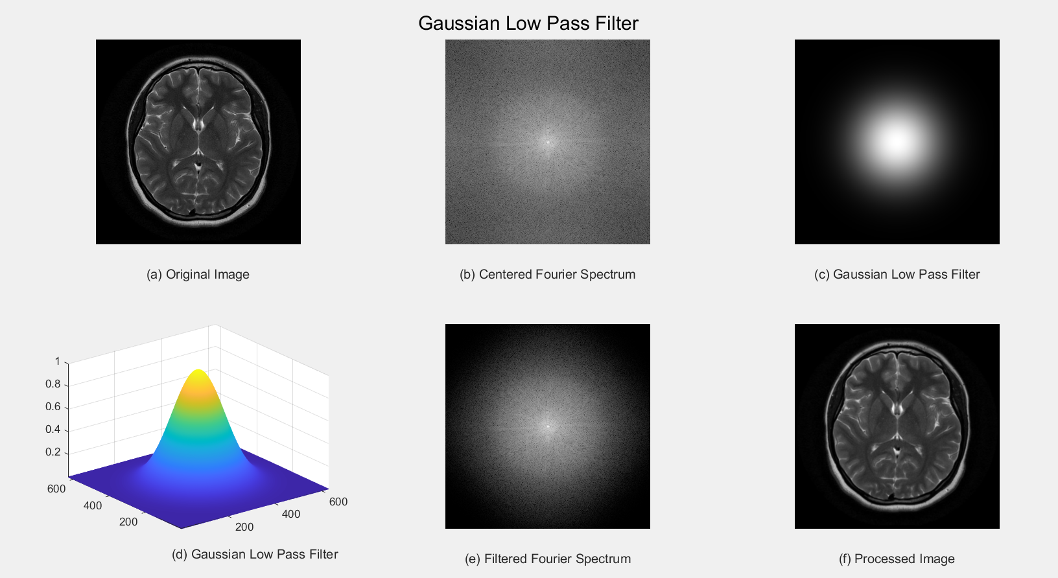

Among the three low-pass filters applied—Ideal Low Pass Filter (ILPF), Butterworth Low Pass Filter (BLPF), and Gaussian Low Pass Filter (GLPF)—the Gaussian Low Pass Filter (GLPF) produced the most visually pleasing result. While the ILPF effectively smoothed the image by allowing all frequencies below the threshold, it introduced noticeable ringing artifacts. The BLPF provided a balanced smoothing effect with a gentle transition controlled by its filter order, but it still exhibited minor distortions. In contrast, the GLPF delivered natural-looking smoothing with a smooth transition and no artifacts, mimicking natural blurring, making it the best choice for image smoothing.

1. **Compress** the above images using Discrete Cosine Transform (DCT), Haar Transform, and DCT-Haar, and find out which one is better in terms of compression ratio and PSNR for the given images.

clc; clear; close all;

% Load Images

img1 = imread('Picture5.png');

img2 = imread('Picture6.png');

img3 = imread('Picture7.png');

% Convert to grayscale

gray_img1 = im2gray(img1);

gray_img2 = im2gray(img2);

gray_img3 = im2gray(img3);

% Apply Discrete Cosine Transform (DCT)

DCT1 = dct2(double(gray_img1));

DCT2 = dct2(double(gray_img2));

DCT3 = dct2(double(gray_img3));

% Keep only a percentage of coefficients for compression

threshold = 20; % Adjust threshold for better compression

compressed_DCT1 = DCT1 .* (abs(DCT1) > threshold);

compressed_DCT2 = DCT2 .* (abs(DCT2) > threshold);

compressed_DCT3 = DCT3 .* (abs(DCT3) > threshold);

% Apply Inverse DCT

reconstructed_DCT1 = uint8(idct2(compressed_DCT1));

reconstructed_DCT2 = uint8(idct2(compressed_DCT2));

reconstructed_DCT3 = uint8(idct2(compressed_DCT3));

% Resize to match original dimensions (to avoid PSNR errors)

reconstructed_DCT1 = imresize(reconstructed_DCT1, size(gray_img1));

reconstructed_DCT2 = imresize(reconstructed_DCT2, size(gray_img2));

reconstructed_DCT3 = imresize(reconstructed_DCT3, size(gray_img3));

% Apply Haar Transform

[H1, L1, H12, H21] = dwt2(double(gray_img1),'haar');

[H2, L2, H22, H23] = dwt2(double(gray_img2),'haar');

[H3, L3, H32, H33] = dwt2(double(gray_img3),'haar');

% Keep a percentage of coefficients

compressed_H1 = H1 .* (abs(H1) > threshold);

compressed_H2 = H2 .* (abs(H2) > threshold);

compressed_H3 = H3 .* (abs(H3) > threshold);

% Apply Inverse Haar Transform

reconstructed_H1 = uint8(idwt2(compressed_H1, L1, H12, H21,'haar'));

reconstructed_H2 = uint8(idwt2(compressed_H2, L2, H22, H23,'haar'));

reconstructed_H3 = uint8(idwt2(compressed_H3, L3, H32, H33,'haar'));

% Resize to match original dimensions

reconstructed_H1 = imresize(reconstructed_H1, size(gray_img1));

reconstructed_H2 = imresize(reconstructed_H2, size(gray_img2));

reconstructed_H3 = imresize(reconstructed_H3, size(gray_img3));

% Apply DCT-Haar Hybrid Compression

DCT_H1 = dct2(H1);

DCT_H2 = dct2(H2);

DCT_H3 = dct2(H3);

compressed_DCT_H1 = DCT_H1 .* (abs(DCT_H1) > threshold);

compressed_DCT_H2 = DCT_H2 .* (abs(DCT_H2) > threshold);

compressed_DCT_H3 = DCT_H3 .* (abs(DCT_H3) > threshold);

% Apply Inverse DCT-Haar

reconstructed_DCT_H1 = uint8(idct2(compressed_DCT_H1));

reconstructed_DCT_H2 = uint8(idct2(compressed_DCT_H2));

reconstructed_DCT_H3 = uint8(idct2(compressed_DCT_H3));

% Resize to match original dimensions

reconstructed_DCT_H1 = imresize(reconstructed_DCT_H1, size(gray_img1));

reconstructed_DCT_H2 = imresize(reconstructed_DCT_H2, size(gray_img2));

reconstructed_DCT_H3 = imresize(reconstructed_DCT_H3, size(gray_img3));

% Compute Compression Ratio & PSNR

compression_ratio_DCT = nnz(compressed_DCT1) / numel(DCT1);

compression_ratio_Haar = nnz(compressed_H1) / numel(H1);

compression_ratio_DCT_Haar = nnz(compressed_DCT_H1) / numel(DCT_H1);

psnr_DCT = psnr(reconstructed_DCT1, gray_img1);

psnr_Haar = psnr(reconstructed_H1, gray_img1);

psnr_DCT_Haar = psnr(reconstructed_DCT_H1, gray_img1);

% Display Results

fprintf('Compression Ratio - DCT: %.2f\n', compression_ratio_DCT);

fprintf('Compression Ratio - Haar: %.2f\n', compression_ratio_Haar);

fprintf('Compression Ratio - DCT-Haar: %.2f\n', compression_ratio_DCT_Haar);

fprintf('PSNR - DCT: %.2f dB\n', psnr_DCT);

fprintf('PSNR - Haar: %.2f dB\n', psnr_Haar);

fprintf('PSNR - DCT-Haar: %.2f dB\n', psnr_DCT_Haar);

figure('Name', 'Compression Comparison');

sgtitle('Compression Results for Three Images');

% First image results

subplot(3,4,1), imshow(gray_img1, []), title('Original Image - 1');

subplot(3,4,2), imshow(reconstructed_DCT1, []), title('DCT Compressed - 1');

subplot(3,4,3), imshow(reconstructed_H1, []), title('Haar Compressed - 1');

subplot(3,4,4), imshow(reconstructed_DCT_H1, []), title('DCT-Haar Compressed - 1');

% Second image results

subplot(3,4,5), imshow(gray_img2, []), title('Original Image - 2');

subplot(3,4,6), imshow(reconstructed_DCT2, []), title('DCT Compressed - 2');

subplot(3,4,7), imshow(reconstructed_H2, []), title('Haar Compressed - 2');

subplot(3,4,8), imshow(reconstructed_DCT_H2, []), title('DCT-Haar Compressed - 2');

% Third image results

subplot(3,4,9), imshow(gray_img3, []), title('Original Image - 3');

subplot(3,4,10), imshow(reconstructed_DCT3, []), title('DCT Compressed - 3');

subplot(3,4,11), imshow(reconstructed_H3, []), title('Haar Compressed - 3');

subplot(3,4,12), imshow(reconstructed_DCT_H3, []), title('DCT-Haar Compressed - 3');

1. **Apply** Gaussian noise to Figure 1, and then use the following to restore the image:

i. Geometric Mean filter

ii. Harmonic Mean filter

iii. Contra-harmonic Mean filter

img = imread('Picture5.png');

img = im2double(img);

noisy_img = imnoise(img, 'gaussian', 0, 0.01);

padsize = 1;

geo_filtered = img;

[M, N] = size(noisy_img);

geo_filtered = zeros(M, N);

padded = padarray(noisy_img, [padsize padsize], 'symmetric');

for i = 2:M+1

for j = 2:N+1

block = padded(i-1:i+1, j-1:j+1);

product = prod(block(:));

geo_filtered(i-1,j-1) = product^(1/9);

end

end

harm_filtered = zeros(M, N);

for i = 2:M+1

for j = 2:N+1

block = padded(i-1:i+1, j-1:j+1);

harm_filtered(i-1,j-1) = 9 / sum(1 ./ (block(:) + eps));

end

end

Q = 1.5;

charm_filtered = zeros(M, N);

for i = 2:M+1

for j = 2:N+1

block = padded(i-1:i+1, j-1:j+1);

num = sum(block(:).^(Q + 1));

den = sum(block(:).^Q) + eps;

charm_filtered(i-1,j-1) = num / den;

end

end

figure;

sgtitle('Gaussian Noise Restoration using Mean Filters');

subplot(2,3,1); imshow(img, []); title('Original Image');

subplot(2,3,2); imshow(noisy_img, []); title('Noisy Image (Gaussian)');

subplot(2,3,3); imshow(geo_filtered, []); title('Geometric Mean Filter');

subplot(2,3,4); imshow(harm_filtered, []); title('Harmonic Mean Filter');

subplot(2,3,5); imshow(charm_filtered, []); title('Contra-harmonic Mean Filter (Q=1.5)');

1. **Apply** Gaussian noise to Figure 1, and then use the following order statistic filters to restore the image:

i. Median filter

ii. Maximum filter

iii. Minimum filter

iv. Midpoint filter

v. Alpha-trimmed filter

vi. Trimmed filter

% Load and prepare the image

img = imread('Picture8.png');

if size(img, 3) == 3

img = img(:,:,1)*0.2989 + img(:,:,2)*0.5870 + img(:,:,3)*0.1140; % Convert to grayscale

end

img = double(img);

[M, N] = size(img);

% Add Gaussian noise

noise_mean = 0;

noise_variance = 0.01 * (max(img(:))^2); % Variance scaled to image intensity

img_noisy = img + sqrt(noise_variance) * randn(M, N) + noise_mean;

img_noisy = max(0, min(255, img_noisy)); % Clip to valid range

% Filter parameters

window_size = 3; % 3x3 window

alpha = 2; % For alpha-trimmed filter (trim 2 pixels from each end)

trimmed_count = 1; % For trimmed filter (trim 1 pixel from each end)

% Initialize output images

img_median = zeros(M, N);

img_max = zeros(M, N);

img_min = zeros(M, N);

img_midpoint = zeros(M, N);

img_alpha_trimmed = zeros(M, N);

img_trimmed = zeros(M, N);

% Pad image to handle borders

pad_size = floor(window_size / 2);

img_padded = padarray(img_noisy, [pad_size pad_size], 'replicate');

% Apply filters

for i = 1:M

for j = 1:N

% Extract window

window = img_padded(i:i+window_size-1, j:j+window_size-1);

window_sorted = sort(window(:));

n = length(window_sorted);

% Median filter

img_median(i, j) = window_sorted(floor((n+1)/2));

% Maximum filter

img_max(i, j) = window_sorted(n);

% Minimum filter

img_min(i, j) = window_sorted(1);

% Midpoint filter

img_midpoint(i, j) = (window_sorted(1) + window_sorted(n)) / 2;

% Alpha-trimmed filter

if alpha > 0 && alpha < floor(n/2)

trimmed_window = window_sorted(alpha+1:n-alpha);

img_alpha_trimmed(i, j) = mean(trimmed_window);

else

img_alpha_trimmed(i, j) = img_median(i, j); % Fallback to median

end

% Trimmed filter (trim 1 pixel from each end, take median)

if trimmed_count > 0 && trimmed_count < floor(n/2)

trimmed_window = window_sorted(trimmed_count+1:n-trimmed_count);

img_trimmed(i, j) = median(trimmed_window);

else

img_trimmed(i, j) = img_median(i, j); % Fallback to median

end

end

end

% Compute PSNR for each restored image

mse_median = mean((img(:) - img_median(:)).^2);

psnr_median = 10 * log10((255^2) / mse_median);

mse_max = mean((img(:) - img_max(:)).^2);

psnr_max = 10 * log10((255^2) / mse_max);

mse_min = mean((img(:) - img_min(:)).^2);

psnr_min = 10 * log10((255^2) / mse_min);

mse_midpoint = mean((img(:) - img_midpoint(:)).^2);

psnr_midpoint = 10 * log10((255^2) / mse_midpoint);

mse_alpha_trimmed = mean((img(:) - img_alpha_trimmed(:)).^2);

psnr_alpha_trimmed = 10 * log10((255^2) / mse_alpha_trimmed);

mse_trimmed = mean((img(:) - img_trimmed(:)).^2);

psnr_trimmed = 10 * log10((255^2) / mse_trimmed);

% Display results

figure('Name', 'Order Statistic Filters for Noise Removal', 'NumberTitle', 'on');

sgtitle('Gaussian Noise Removal with Order Statistic Filters', 'FontSize', 18);

subplot(2, 4, 1), imshow(uint8(img)), title('Original Image');

subplot(2, 4, 2), imshow(uint8(img_median)), title(sprintf('Median Filter\nPSNR: %.2f dB', psnr_median));

subplot(2, 4, 3), imshow(uint8(img_max)), title(sprintf('Maximum Filter\nPSNR: %.2f dB', psnr_max));

subplot(2, 4, 4), imshow(uint8(img_min)), title(sprintf('Minimum Filter\nPSNR: %.2f dB', psnr_min));

subplot(2, 4, 5), imshow(uint8(img_midpoint)), title(sprintf('Midpoint Filter\nPSNR: %.2f dB', psnr_midpoint));

subplot(2, 4, 6), imshow(uint8(img_alpha_trimmed)), title(sprintf('Alpha-trimmed Filter\nPSNR: %.2f dB', psnr_alpha_trimmed));

subplot(2, 4, 7), imshow(uint8(img_trimmed)), title(sprintf('Trimmed Filter\nPSNR: %.2f dB', psnr_trimmed));

% Print PSNR results

fprintf('PSNR Results for Order Statistic Filters:\n');

fprintf('Median Filter: %.2f dB\n', psnr_median);

fprintf('Maximum Filter: %.2f dB\n', psnr_max);

fprintf('Minimum Filter: %.2f dB\n', psnr_min);

fprintf('Midpoint Filter: %.2f dB\n', psnr_midpoint);

fprintf('Alpha-trimmed Filter: %.2f dB\n', psnr_alpha_trimmed);

fprintf('Trimmed Filter: %.2f dB\n', psnr_trimmed);

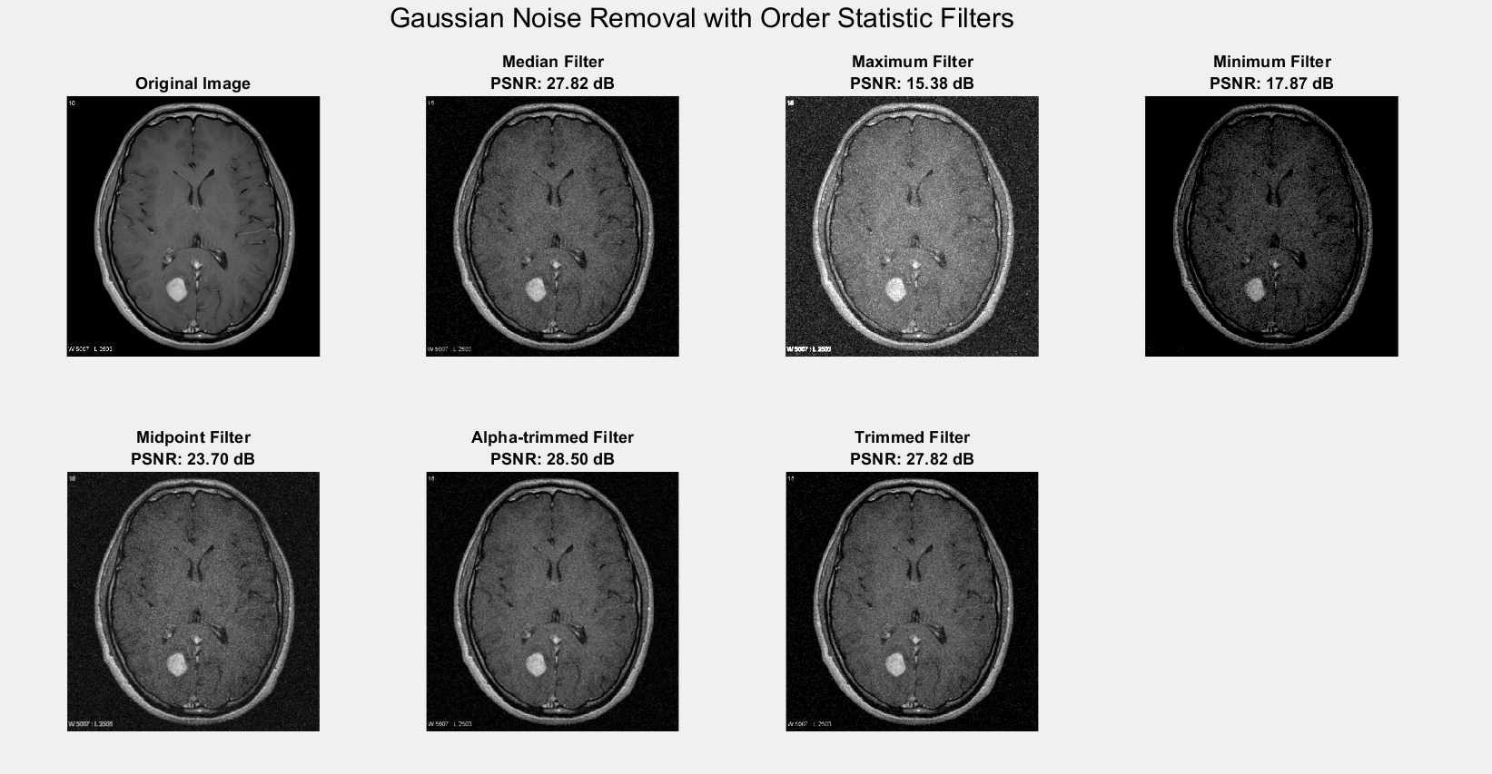

1. By observing and comparing each of the outputs, determine which filter restores the image Figure 1 closest to its original state. Mention the reasoning behind your observation.

After applying and comparing the outputs of all six order-statistic filters on the Gaussian-noised image, the **Median Filter** is observed to restore the image most effectively. It successfully reduces noise while preserving the essential details and edges of the original image, making it visually the closest to the noise-free version. The **Maximum** and **Minimum Filters**, while capable of handling extreme pixel values, often overemphasize either bright or dark regions, leading to loss of image detail. The **Midpoint Filter**, being an average of extremes, smoothens the image but may blur fine structures. Both the **Alpha-trimmed** and **Trimmed Mean Filters** offer moderate performance but may excessively smooth the image depending on the trim level. Overall, due to its robustness and ability to balance noise removal with detail preservation, the **Median Filter** is the most suitable for restoring images degraded by Gaussian noise in this case.